Electrocatalytic Oxygen Evolution with an Immobilized TAML Activator

Ethan L Demeter1, Shayna L Hilburg2, Newell R Washburn3, Terrence J Collins3, John R Kitchin1*

Carnegie Mellon University, Departments of Chemical Engineering1, Materials Science and Engineering2, and Chemistry3, 5000 Forbes Ave Pittsburgh PA 15213

AUTHOR EMAIL ADDRESS: jkitchin@andrew.cmu.edu

*To whom correspondence should be addressed.

**Supporting Information**

1. **Results from experiments using TAML as a homogeneous electrocatalyst**

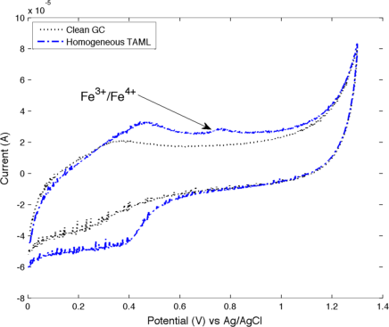

Figure S1. Cyclic voltammogram of clean glassy carbon (dotted black) and 0.5 g TAML/mL in 0.1 M HNO3 electrolyte (dot-dashed blue). The scan rate was set to 100 mV/s.

Figure S1 shows the attempted use of TAML as a homogeneous electrocatalyst for the oxygen evolution reaction. The results of the cyclic voltammogram indicate that there is some oxidation of Fe taking place at the glassy carbon surface. However, this small amount of TAML involvement does not result in an increase in activity to a level that greatly distinguishes it from clean glassy carbon in the neat 0.1 M HNO3 solution. Comparing the homogeneous TAML experiments to those of the immobilized TAML described in the paper, it is clear that immobilizing the TAML activator results in much higher Fe oxidation, and in clear and present catalytic activity.

**II. Control experiments using Fe-containing compounds**

Control experiments were conducted by supporting 5,10,15,20-2,3,7,8,12,13,17,18-octaethyl-21H,23H-porphine iron(III) chloride (Sigma-Aldrich) and Fe(III)Cl3 onto carbon black at similar Fe loadings to the supported TAML electrocatalyst, **1**. The supported materials were incorporated into a catalyst ink by the addition of 8 wt% Nafion, as an ionomer binder, and 5 mL isopropyl alcohol. The mixtures were then sonicated for 1 hr to ensure dispersion, and then the resulting inks were painted onto strips of carbon paper to the desired catalyst loading. Electrochemical characterization was performed by running a series of cyclic voltammograms to compare the redox behaviors with those of the TAML impregnated materials. Following this characterization, steady-state electrolysis experiments were performed, with the current set to 5 mA/cm2, in conjunction with gas analysis techniques (*1*) to quantitatively determine the gas evolution.

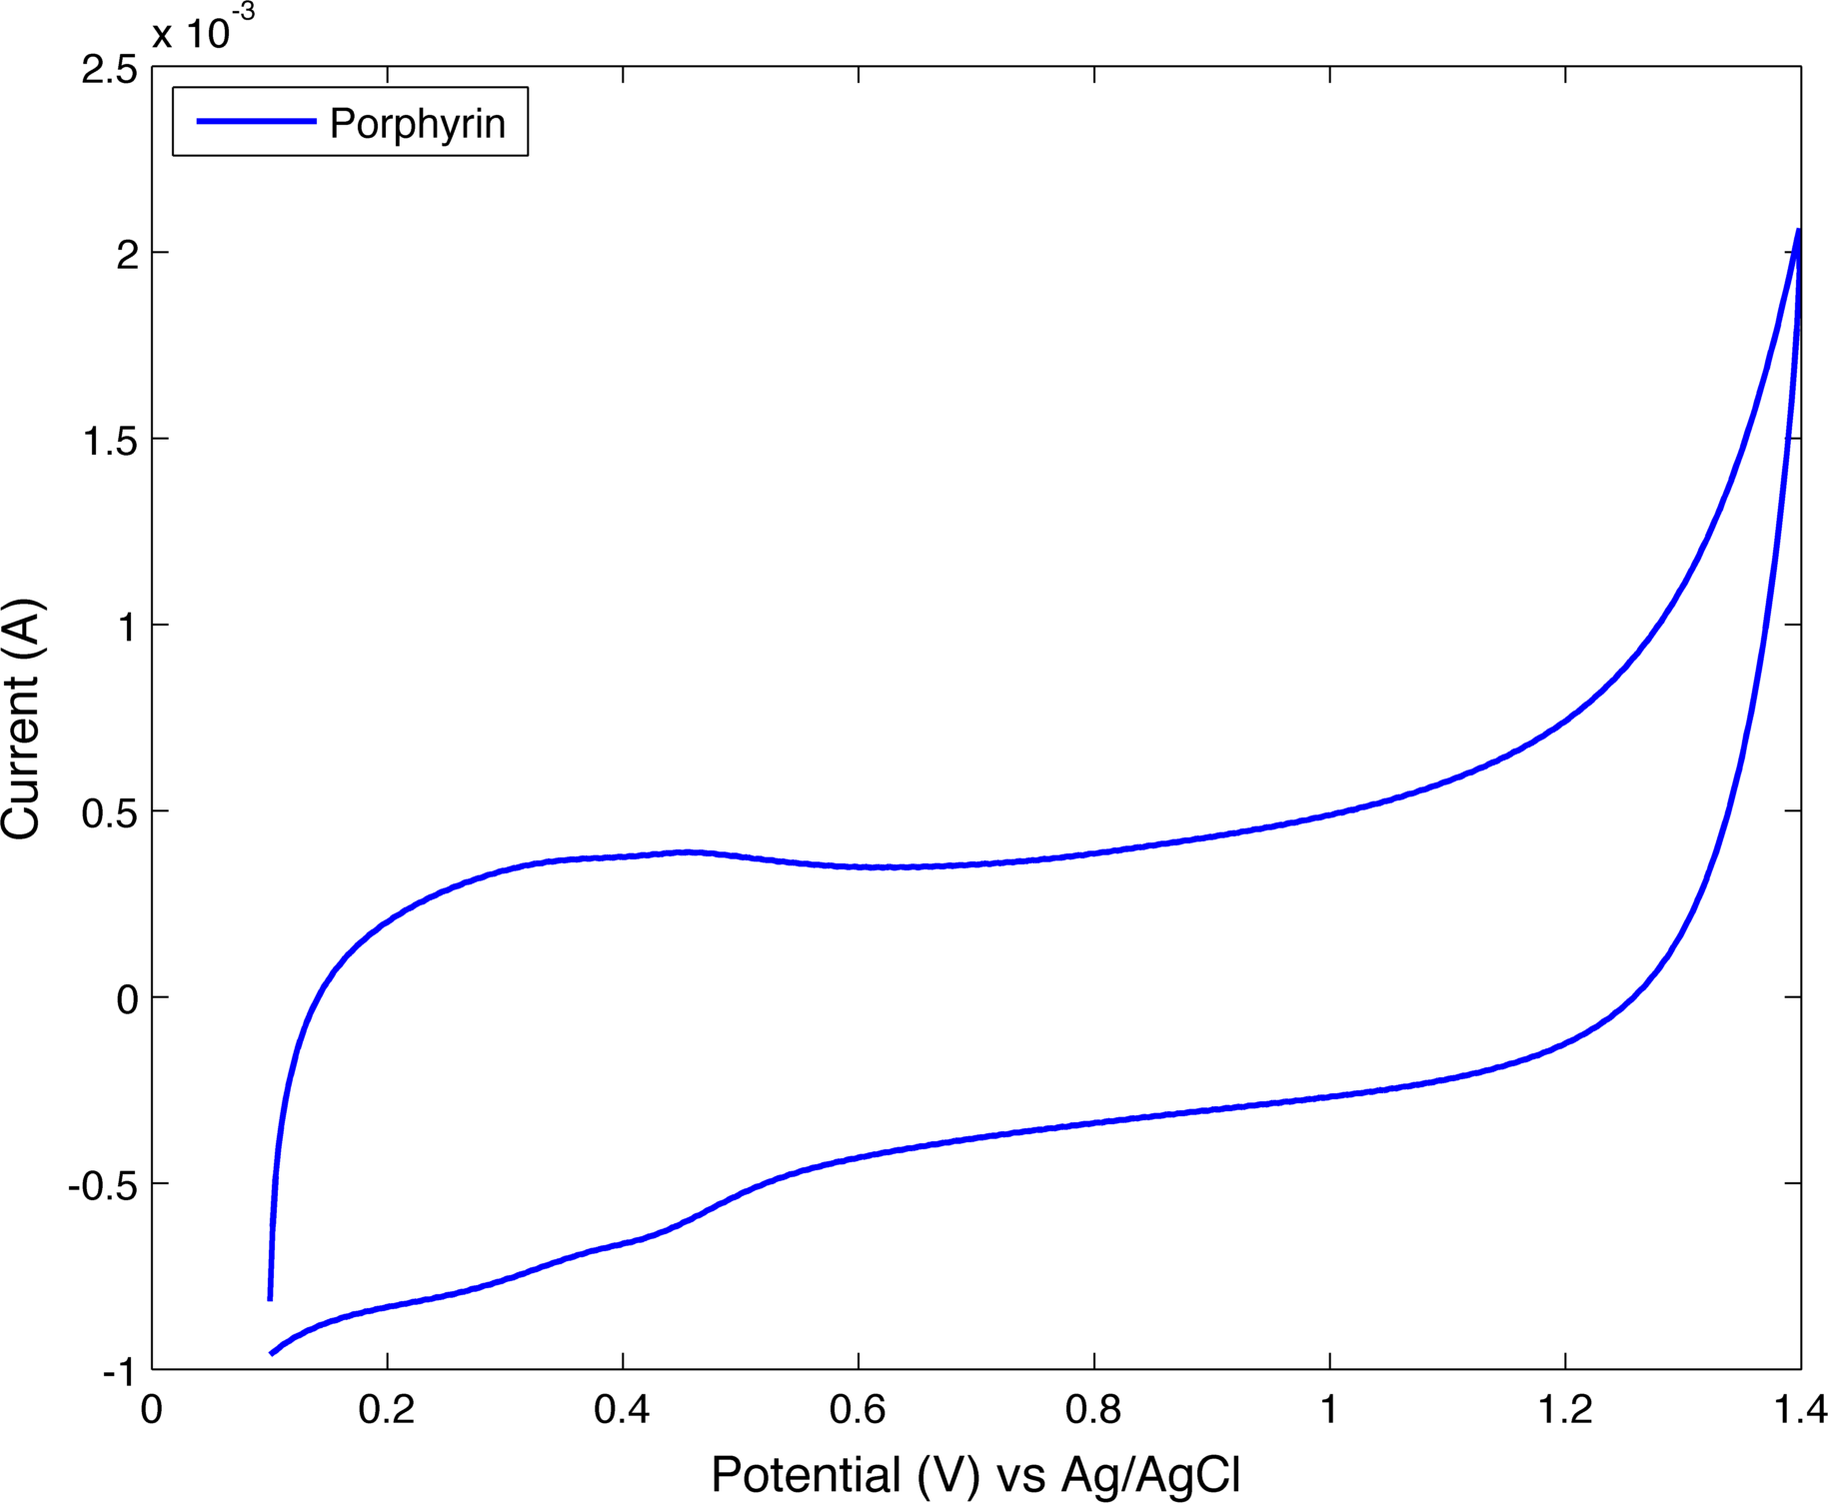

Figure S2. Cyclic voltammogram of supported 2,3,7,8,12,13,17,18-octaethyl-21H,23H-porphine iron(III) chloride in 0.1 M HNO3 electrolyte. The scan rate is set to 50 mV/s.

The CV of the porphyrin material shown in Figure S2 shows no evidence of Fe oxidation-reduction chemistry, but a catalytic wave can be observed beginning ~1.3 V. Analysis of the head space gas composition showed no oxygen production and that this oxidation current likely resulted from carbon oxidation.

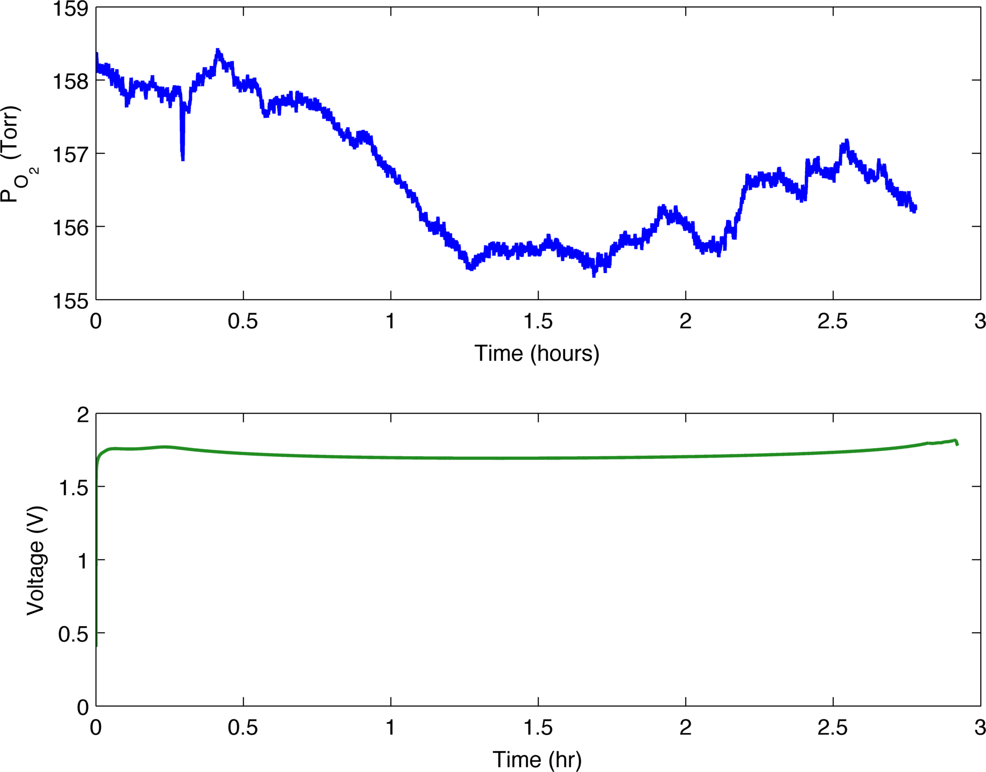

Figure S. Combined FOXY (blue) and galvanostatic (green) data for steady-state constant current (5mA) electrolysis experiments on supported Tetraphenyl-21H,23H-porphine iron(III) chloride.

From the results in Figure S3, it is clear that there is no significant production of O2 throughout the course of the electrolysis experiment. The potential remained relatively constant throughout, but the real time data suggested no selectivity toward the oxygen evolution reaction.

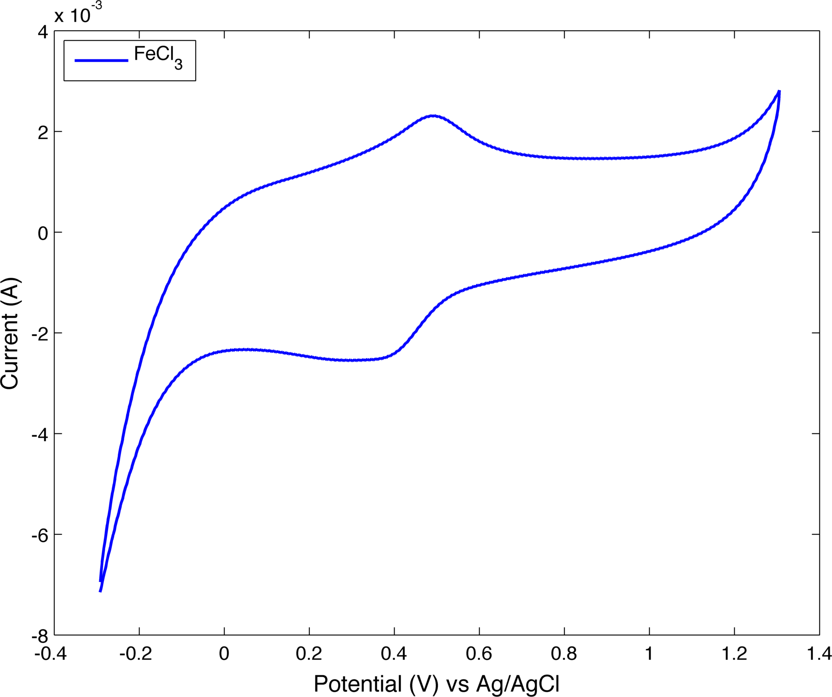

Figure S. Cyclic voltammogram of supported FeCl3 in 0.1 M HNO3 electrolyte. The scan rate is set to 50 mV/s. The oxidation wave is indicative of an Fe+2/Fe+3 transition.

The CV of the supported FeCl3 shows an oxidation waved indicative of the +2/+3 transition for iron (~0.5 V) and a catalytic wave that begins at ~1.3 V. Here there is evidence of Fe oxidation-reduction chemistry, and gas analysis experiments followed to discern whether this correlated as selectivity to the OER.

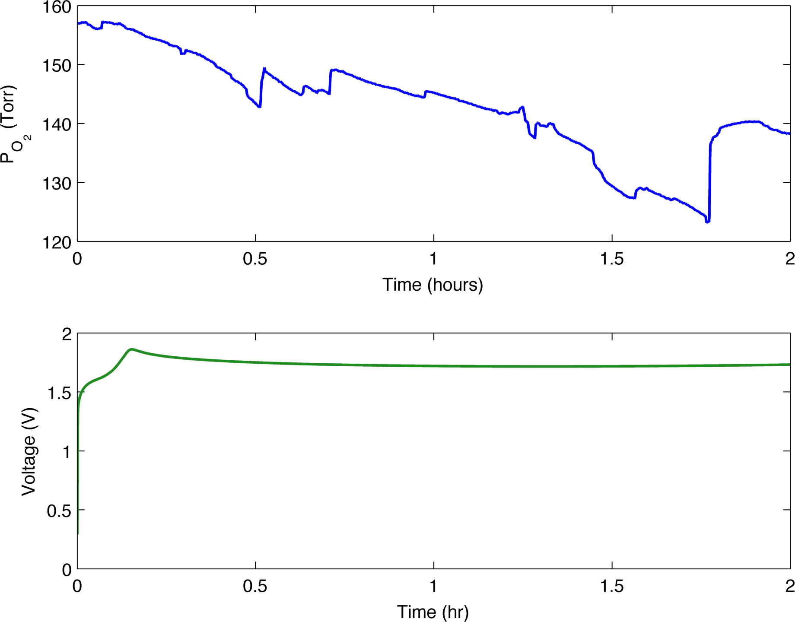

Figure S. Combined FOXY (blue) and galvanostatic (green) data for steady-state constant current (5 mA) electrolysis experiments on supported FeCl3.

In Figure S5, the real-time data from the fluorescent O2 probe shows no indication of O2 production throughout the course of the electrolysis experiment and the potential value is constant. Gas chromatography data confirmed these results and showed an increased production of CO2 over time.

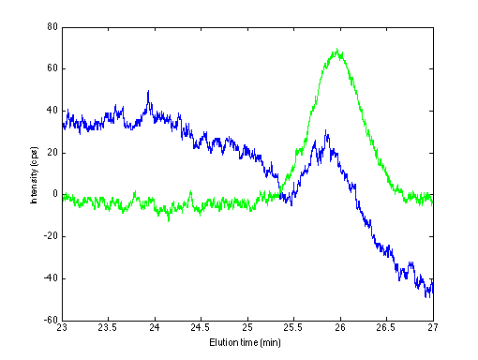

Figure S. Gas chromatographs for supported FeCl3 electrolysis experiments taken after 1 hr (blue) and 2 hr (green). Injection volume was 100 μL, injector/detector temperature was 100 °C and the column temperature was 95 °C.

As can be seen in Figure S6, the CO2 peak was observed after only 1 hour of electrolysis, corresponding to a CO2 concentration of ~0.4%, which continued to rise up to a value of ~0.9% at the conclusion of the 2 hour experiment.

1. **Improvement in selectivity towards oxygen with TAML ink**

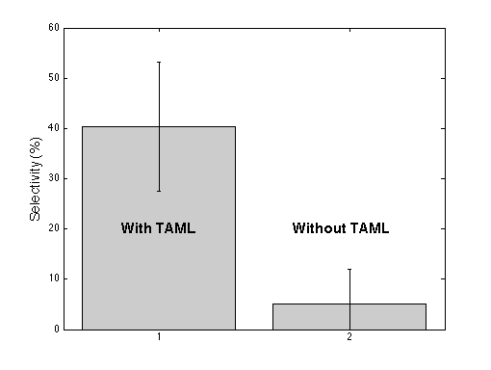

Figure S7. Comparison of the selectivity for O2 evolution over electrodes with and without 1 present.

In Figure S7 we show that the selectivity of the current towards oxygen production is significantly higher for the GC-Ink-**1** electrodethan with the GC-CB electrode. While 100% selectivity for O2 production was not found, the presence of **1** produced a 3-fold improvement over the GC-CB electrode.

1. **Examples of Gas Chromatographic data using TAML as a supported heterogeneous OER electrocatalyst**

C:\Users\kitchin-init\Documents\MATLAB\gcdata\TAML CO2 detection O2N2 peaks.tif

C:\Users\kitchin-init\Documents\MATLAB\gcdata\TAML CO2 detection CO2 peak 2.tif

**Figures S8a,b. a)** Gas chromatographs from two experimental runs following 2-hour experiments using immobilized TAML as the electrode surface. **b)** Data from 0.5% CO2 with balance N2 and lab air are also included for comparison purposes.

Conditions for the GC Analyses: The experimental instrument settings were; Injector/Detector temperature, 100 °C, Column temperature, 45 °C, operating current, 120 mA, injection volume, 100 μL. Three gas species were of interest in our GC experiments, O2, N2, and CO2. O2 and N2 have similar elution times (seen here at 4.7 and 5 minutes, respectively), which results in an overlapping of their corresponding elution peaks. These two peaks were quantitatively separated using a method described by Goodman et al.(*1*) The CO2 peak took far longer to elute and the column temperature had also to be increased for CO2 to elute. To accomplish this, the column was given sufficient time for the N2 elution to complete (~6 min) then the column temperature was increased to 95 °C after which the CO2 eluted at t~25 minutes.

**Reference**

(1) Goodman, K. J.; Brenna, J. T. Curve Fitting for Restoration of Accuracy for Overlapping Peaks in Gas Chromatography/Combustion Isotope Ratio Mass Spectrometry. *Analytical Chemistry* **1994**, *66*, 1294–1301.